Decision Tree
A Decision Tree is a supervised machine learning algorithm used for:
- Classification problems
Example: Yes/No, Spam/Not Spam
- Regression problems
Example: House price prediction
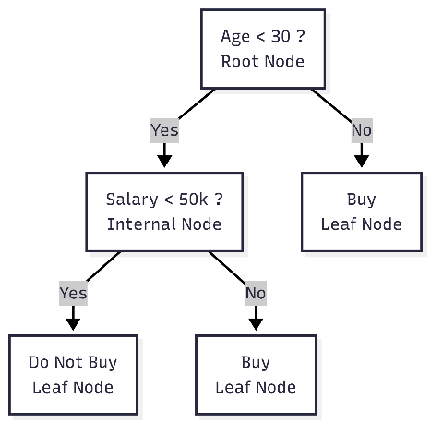
What is Root Node ?
The feature with highest Information Gain becomes the Root Node.
what is Internal Node ?
A decision node inside the tree.
what is Leaf Node ?
Final prediction/output.
KeyWords Explanation
what is Entrophy ?
Entropy measures impurity or disorder in the dataset.
- Low entropy → Pure data
- High entropy → Mixed data

Formula
$$Entropy\left(S\right)=-\sum{p_{i}}\log_{2}\left(p_{i}\right)$$
Binary Classification
$$Entropy\left(S\right)=-p\left(Yes\right)\log_{2}\left(p\left(Yes\right)\right)-p\left(No\right)\log_{2}\left(p\left(No\right)\right)$$
Information Gain Formula
$$Information Gain=Entropy\left(Parent\right)-Weighted Entropy\left(Children\right)$$

Data Set
ID | Age | Salary | Experience | Buy Laptop
1 | Young | Low | Low | No
2 | Young | Low | Medium | No
3 | Young | Medium | Medium | Yes
4 | Young | High | High | Yes
5 | Middle | Low | Medium | Yes
6 | Middle | Medium | High | Yes
7 | Middle | High | High | Yes
8 | Old | Medium | Low | No
9 | Old | High | Medium | Yes
10 | Old | High | High | Yes
Problem
Predict whether a customer will Buy Laptop = Yes / No
Features
- Age
- Salary
- Experience
Target
Buy Laptop = Yes / No
Data Segregation
Buy Laptop = Yes
Rows | Count
3, 4, 5, 6, 7, 9, 10 | 7
Buy Laptop = No
Rows | Count
1, 2, 8 | 3
Total Records
Total Rows
10
Step 1
Calculate Parent Entrophy
$$Entropy\left(S\right)=-{p\left(Yes\right)log}_{2}\left(p\left(Yes\right)\right)-{p\left(No\right)log}_{2}\left(p\left(No\right)\right)$$
Find Probability
p(Yes) = 7/10 = 0.7
p(No) = 3/10 = 0.3
Substitute Values
$$Entropy\left(S\right)=-\left(0.7\log_{2}\left(0.7\right)+0.3\log_{2}\left(0.3\right)\right)$$
$$Entropy\left(S\right)=-\left(0.7×\left(-0.514\right)+0.3×\left(-1.737\right)\right)=0.881$$Parent Entropy = 0.881
Calcuate Informatin Gain for Age
Age Values
- Young
- Middle
- Old
Case 1 : Age =Young , Old , Middle
Age | IDs | YES | NO | Count
Young | 1,2,3,4 | 2 | 2 | 4
Middle | 5,6,7 | 3 | 0 | 3
Old | 8,9,10 | 2 | 1 | 3
Case 1 Age = Young
YES = 2
NO = 2
Count = 4
$$Entropy\left(Young\right)=-\left(\frac{2}{4}\log_{2}{\frac{2}{4}}+\frac{2}{4}\log_{2}{\frac{2}{4}}\right)$$
$$Entropy\left(\text{Young}\right)=-\left(0.5×\left(-1\right)+0.5×\left(-1\right)\right)=1$$
$$Entropy\left(\text{Young}\right)=1$$Similarly,
$$Entropy\left(\text{Middle}\right)=0 , Entropy\left(\text{Old}\right)=0.918$$
Weighted Entropy for Age
$$Weighted Entropy=\sum_{v∈Values\left(A\right)}{\frac{\left|S_{v}\right|}{\left|S\right|}} Entropy\left(S_{v}\right) \\ Weighted Entropy\left(Age\right)=\left(\frac{4}{10}×1\right)+\left(\frac{3}{10}×0\right)+\left(\frac{3}{10}×0.918\right)$$
$$Weighted Entropy\left(Age\right)=0.4+0+0.275=0.675$$Information Gain for Age
$$IG\left(Age\right)=Entropy\left(Parent\right)-Weighted Entropy\left(Age\right)$$
$$IG\left(Age\right)=0.881-0.675=0.206$$
Similarrly Final Information Gain Comparison Table
Feature | Weighted Entropy | Information Gain
Age | 0.675 | 0.206
Salary | 0.55 | 0.331
Experience | 0.324 | 0.557 ✅
Best Feature
Highest Information Gain:
Experience = 0.557
So Root Node becomes:
Experience
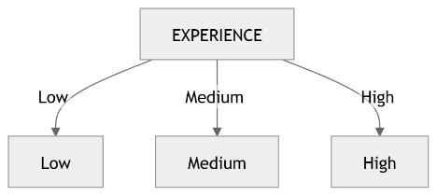

Step 1: Branch → Experience = Low
ID | Age | Salary | Buy Laptop
1 | Young | Low | No
8 | Old | Medium | No
Output | Count
Yes | 4
No | 0

$P\left(\text{Yes}\right)=0$ , $P\left(\text{No}\right)=1$ ,
$Entropy=-\left(0\log_{2}\left(0\right)+1\log_{2}\left(1\right)\right)=0$
$\text{Experience=Low→No}$
Step 2: Branch → Experience = Medium
ID | Experience | Age | Salary | Buy Laptop
2 | Medium | Young | Low | No
3 | Medium | Young | Medium | Yes
5 | Medium | Middle | Low | Yes
9 | Medium | Old | High | Yes
Count YES / NO
Output | Count
Yes | 3
No | 1
$P\left(\text{Yes}\right)=\frac{3}{4}=0.75$ , $P\left(\text{No}\right)=\frac{1}{4}=0.25$ ,
$$\text{Entropy}\left(S\right)=-\left(0.75\log_{2}\left(0.75\right)+0.25\log_{2}\left(0.25\right)\right) \\ \text{Entropy}\left(S\right)=-\left[\left(0.75×-0.415\right)+\left(0.25×-2\right)\right] \\ = 0.811$$

Branch 2 → Experience = High
ID | Age | Salary | Buy Laptop
4 | Young | High | Yes
6 | Middle | Medium | Yes
7 | Middle | High | Yes
10 | Old | High | Yes
Count YES / NO
Output | Count
Yes | 4
No | 0
$$P\left(\text{Yes}\right)=\frac{4}{4}=1$$ , $P\left(\text{No}\right)=\frac{0}{4}=0$
$$\text{Entropy}=-\left(1\log_{2}\left(1\right)+0\log_{2}\left(0\right)\right) \\ \text{Entropy}=0$$
In a Decision Tree, splitting stops when a node becomes pure.
A pure node means:
- All outputs belong to the same class
- Entropy = 0
- No uncertainty exists
- Further splitting gives no additional Information Gain
Experience Branch | Outputs | YES | NO | Entropy | Status | Reason
Low | No, No | 0 | 2 | 0 | Stop | Pure node (all No)
High | Yes, Yes, Yes, Yes | 4 | 0 | 0 | Stop | Pure node (all Yes)
Medium | No, Yes, Yes, Yes | 3 | 1 | 0.811 | Continue | Mixed classes present

Technical Rule
$\text{Entropy}=0⇒\text{Pure Node}⇒\text{Stop Splitting}$
$$\text{Entropy}>0⇒\text{Impure Node}⇒\text{Continue Splitting}$$

